Schedule Batch Jobs on Windows

## Prepare Batch File

1. Create a batch file “*.bat”.

Sample Python Scripts

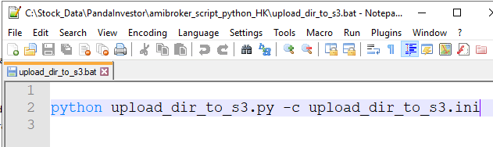

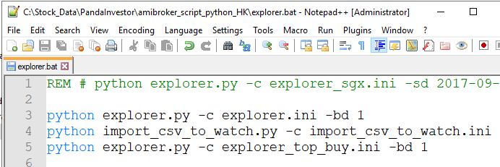

Sample JavaScripts

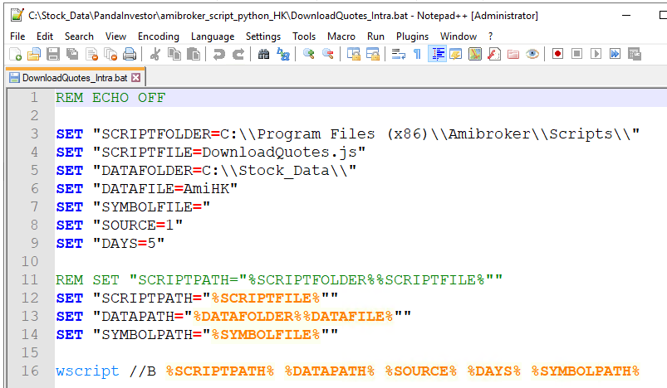

## Setup Scheduler

1. Start Task Scheduler.
2. Click on the menu “Action > Create Basic Task...” to create a new Basic Task.

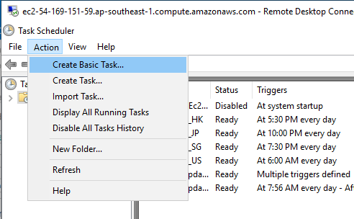

1. Enter Name and Description of the task.

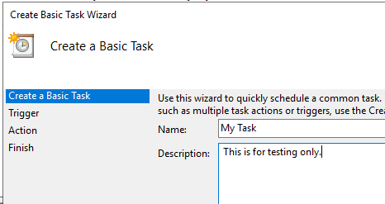

1. Choose frequency of the trigger, e.g. Daily

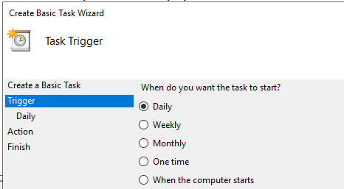

1. Set the start date and time.

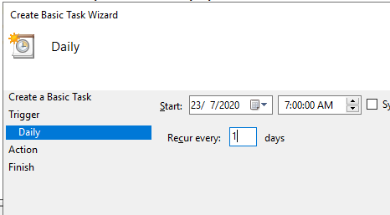

1. For the Action, only “Start a program” is working now.

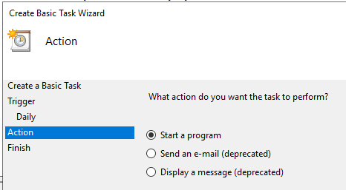

1. Select a script file to be run.
   1. **IMPORTANT:** Set “Start in” to the directory where your script file is in.

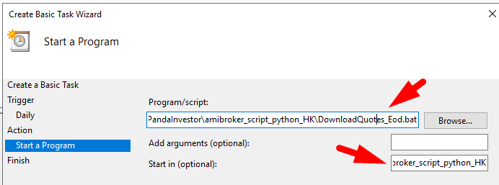

1. You can test run your batch job.

